What does the check_magic() function in the following code do  
  
 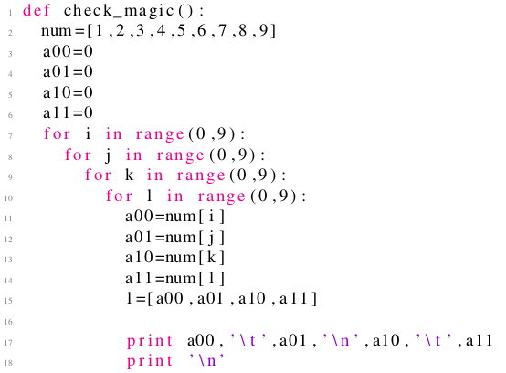

 displays all 2 × 2 matrices where elements are from 1 to 9.

 displays all 2 × 2 matrices where elements are from 1 to 9 but no element is repeated

 displays magic squares of size 2

 none of the above

Yes, the answer is correct.  
Score: 1

Accepted Answers:

*displays all 2 × 2 matrices where elements are from 1 to 9.*

***1 point***

What does the following code do?  
  
 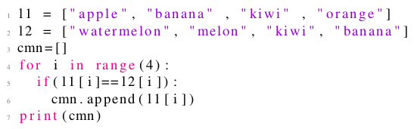

 displays common fruits in both the lists l1 and l2

 displays fruits which are in l1 but not in l2

 displays fruits which are in l2 but not in l1

 none of the above

Yes, the answer is correct.  
Score: 1

Accepted Answers:

*none of the above*

***1 point***

Leap years are the years

1. which divisible by 4 but not divisible by 100, and, those

2. divisible by 400

   Which of the following code does not represent a code displaying all the leap years from 1 to 2000.

  
  
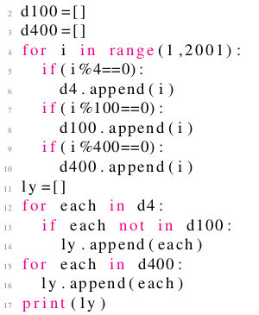

  
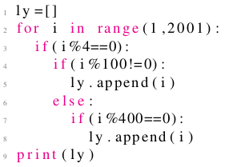

  
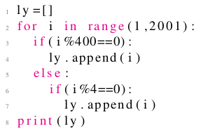

  
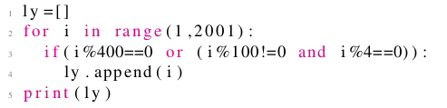

Yes, the answer is correct.  
Score: 1

Accepted Answers:

**

***1 point***

What does the following function do  
   
 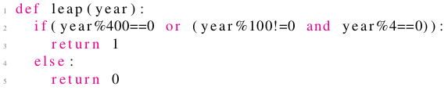

 returns true for century year and false for non century year

 returns true for leap year and false for non leap year

 returns false for century year and true for non century year

 none of the above

Yes, the answer is correct.  
Score: 1

Accepted Answers:

*returns true for leap year and false for non leap year*

***1 point***

Which of the following code correctly represents how one can display the number of dashes equal to that of the letters in the movie name?



movies =[" t i t a n i c " , " chinatown " , " a v e n g e r s " , " 3 i d i o t s " , " c o n j u r i n g " , " j u n g l e b o o k " , " m a t r i x " ]

ch =random . c h o i c e ( m o v i e s )

f o r  i  in  r a n g e ( l e n ( ch ) ) :

print ( ’_ ’) ,



movies =[" t i t a n i c " , " chinatown " , " a v e n g e r s " , " 3 i d i o t s " , " c o n j u r i n g " , " j u n g l e b o o k " , " m a t r i x " ]

ch =random . c h o i c e ( m o v i e s )

for i in range (100):

print ( ’_ ’) ,



movies =[" t i t a n i c " , " chinatown " , " a v e n g e r s " , " 3 i d i o t s " , " c o n j u r i n g " , " j u n g l e b o o k " , " m a t r i x " ]

ch =random . c h o i c e ( m o v i e s )

for  ch  in  r a n g e ( l e n ( ch ) ) :

print ( ’_ ’) ,

 none of these

Yes, the answer is correct.  
Score: 1

Accepted Answers:

*movies =[" t i t a n i c " , " chinatown " , " a v e n g e r s " , " 3 i d i o t s " , " c o n j u r i n g " , " j u n g l e b o o k " , " m a t r i x " ]*

*ch =random . c h o i c e ( m o v i e s )*

*f o r  i  in  r a n g e ( l e n ( ch ) ) :*

*print ( ’_ ’) ,*

***1 point***

Given a list of movies, which of the following represents a code which randonly chooses a movie amongst all?



movies =[" t i t a n i c " , " chinatown " , " a v e n g e r s " , " 3 i d i o t s " , " c o n j u r i n g " , " j u n g l e b o o k " , " m a t r i x " ]

ch = m o v i e s [ random . r a n d i n t ( 0 , l e n ( m o v i e s ) ) ]



movies =[" t i t a n i c " , " chinatown " , " a v e n g e r s " , " 3 i d i o t s " , " c o n j u r i n g " , " j u n g l e b o o k " , " m a t r i x " ]

ch = m o v i e s [ random . u n i f o r m ( 0 , l e n ( m o v i e s ) ) ]



movies =[" t i t a n i c " , " chinatown " , " a v e n g e r s " , " 3 i d i o t s " , " c o n j u r i n g " , " j u n g l e b o o k " , " m a t r i x " ]

ch = m o v i e s [ random . c h o i c e ( 0 , l e n ( m o v i e s ) ) ]

 none of these

No, the answer is incorrect.  
Score: 0

Accepted Answers:

*none of these*

***1 point***

What does the following code do?  
  
 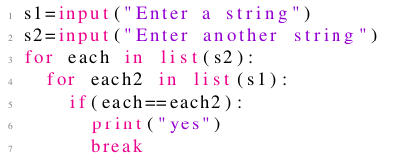

 prints yes if both strings are same

 prints yes if both strings have atleast one common character

 prints yes if first string is contained in the second

 none of the above

Yes, the answer is correct.  
Score: 1

Accepted Answers:

*prints yes if both strings have atleast one common character*

***1 point***

Which numbers from 1 to 100 does the following code print?  
  
 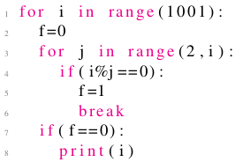

 prime numbers

 perfect squares

 numbers which are factorial of some other number

 perfect cubes

Yes, the answer is correct.  
Score: 1

Accepted Answers:

*prime numbers*

***1 point***

Which numbers from 1 to 100 does the following code print?  
  
 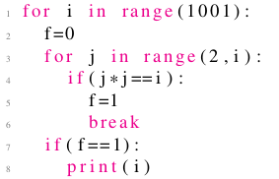

 prime numbers

 perfect squares

 numbers which are factorial of some other number

 perfect cubes

Yes, the answer is correct.  
Score: 1

Accepted Answers:

*perfect squares*

***1 point***

Assume a drunkard whose movement is defined on the number line, i.e. he can either move forward or backward. Assume he is  
    standing at a position *p*. He takes 2 steps forward followed by 4 steps backward. He falls into the pit as soon as he steps  
    on the position zero. Which of the following codes correctly represents his walk? A.



p= i n t ( i n p u t ( ) )

while (p >0):

p=p+2

 p r i n t ( " Location =" , p )

p=p−4

 p r i n t ( " Location =" , p )

p r i n t (" Fell in p i t at location " , p )



p= i n t ( i n p u t ( ) )

while (p >0):

p=p−2

 p r i n t ( " Location =" , p )

p=p+4

 p r i n t ( " Location =" , p )

p r i n t (" Fell in p i t at location " , p )



p= i n t ( i n p u t ( ) )

while (p >0):

for i in range ( 2 ) :

p=p+1

   p r i n t ( " Loc = " , p )

   i f ( p ==0):

break

for i in range ( 4 ) :

p=p−1

 p r i n t ( " Loc = " , p )

 i f ( p ==0):

break

p r i n t (" Fell in p i t at location " , p )

 none of these

No, the answer is incorrect.  
Score: 0

Accepted Answers:

*p= i n t ( i n p u t ( ) )*

*while (p >0):*

*p=p+2*

*p r i n t ( " Location =" , p )*

*p=p−4*

*p r i n t ( " Location =" , p )*

*p r i n t (" Fell in p i t at location " , p )*